Chapter 12, Solution 72.

From Problem 12.11,
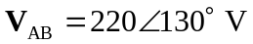 and 